Name:__________________ #____
Biography Book Report: Part 1
Research Note-Taking
*As you read your biography, answer the following questions using evidence from your book. You will be able to use this research to create your ‘Living Biography’ presentation/speech.
Title:___________________________________________________
Author:________________________________________________
Birthplace:____________________________________________
Birthdate:_____________________________________________
Early Life
Describe the early life of the book’s subject. Include family members, education, important events, and so on.

Explain why this person is famous:
What work did the person do? How did he or she become well known? What were that person’s accomplishments?

Major Challenges your person faced:
What are some problems that your person encountered during his/her life? These problems can be both personal and professional (job).

How your person overcame these problems?:
What did your person do to solve these problems? Were they able to solve all of the problems?

Important Character Traits
1. Character trait #1:_________________
Specific evidence from text to prove character trait:
*___________________________________________________________________
*___________________________________________________________________
*___________________________________________________________________
*___________________________________________________________________
2. Character trait #2: _________________
Specific evidence from text to prove character trait:
*___________________________________________________________________
*___________________________________________________________________
*___________________________________________________________________
*___________________________________________________________________

3 most interesting things about your person
1. __________________________________________________________________________

2. __________________________________________________________________________

3. __________________________________________________________________________

Biography Book Report: Part 2
Presentation/Speech
Directions: You will need to dress up as your famous person and present your research as if you were that famous person. Presentations should be done in first person (say “I was born” not “Juan Ponce de Leon was born”). This presentation needs to be organized, thorough, and well-practiced. The information needs to be the student’s words, not directly from the book. The exception is if they choose to share a famous quote or quotes, just let the audience know it is a quote. Students will also present their bottle buddy at this time as well.

Use the checklist below to make sure you have everything ready for your presentation:

Checklist:
___ Speech typed or neatly written on a separate sheet of paper
___ Speech written in 1st person and paragraph form
___ Costume or outfit prepared for presentation

Biography Book Report: Part 3
Bottle Buddy
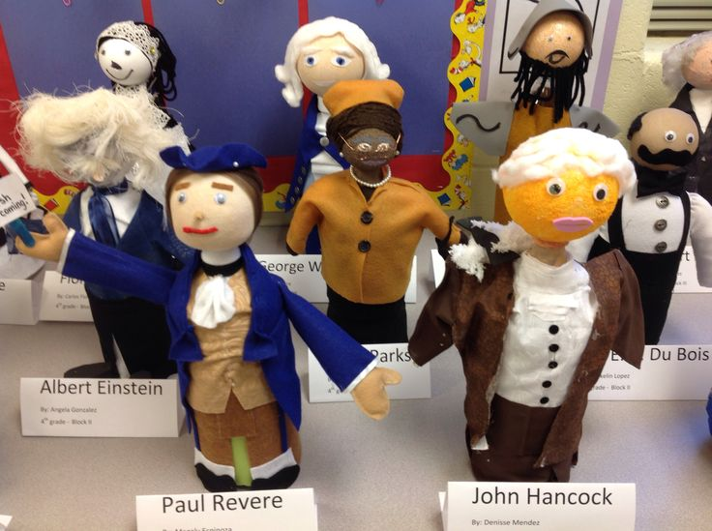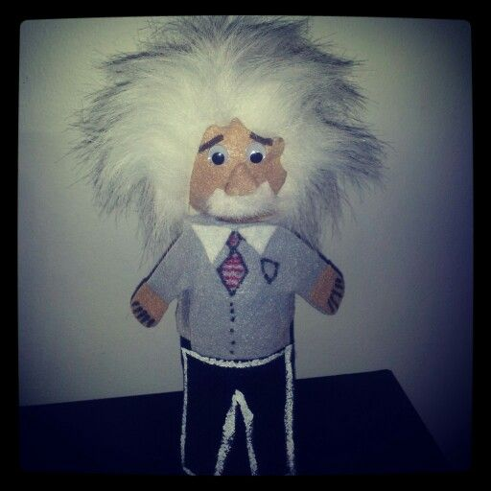

Bottle buddies are miniature representations of your person. They should be creative and completed neatly. Please see below for checklist of requirements.

CHECKLIST
___ 2 or 3 liter bottle used for body (emptied and
cleaned)
___ 3-D lightweight, round object used for head
(ex: Styrofoam ball)
___ Sand or dry rice inside of bottle so it stands on
its own (not too much or it will be too heavy).
___ Bottle buddy decorated with appropriate clothing
or decorations to represent person (can include
props)

Biography Book Report: Part 4
Acrostic Poem
Create an Acrostic Poem using the letters of your famous person on construction paper or a poster board. Write a phrase or sentence to describe the person using each letter. Decorate your poem creatively. This will also be presented with the Bottle Buddies and Living Biography.
Example:
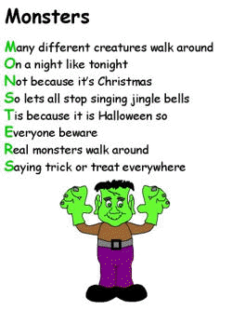
Checklist:
___ Poster board or large sheet of construction
paper used for poem
___ Entire name written (first and last)
___ Phrase or sentence used to describe person
for each letter (different fact each time)
___ Poster board decorated creatively
___ Information written neatly or typed

